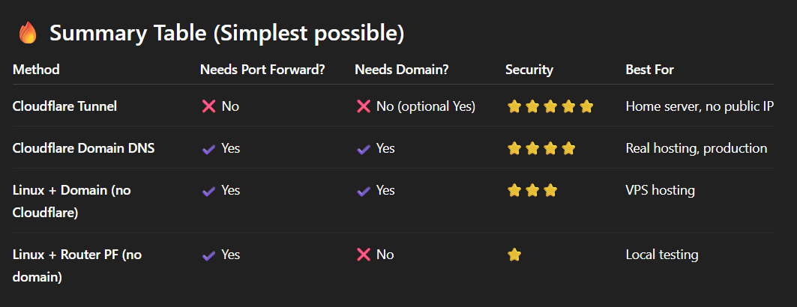
Full Documentation: VM Setup to Online Deployment
(This document will contain all steps from the beginning — creating the VM, changing network mode, installing Docker, setting up backend/frontend, fixing permissions, building with docker-compose, and accessing online. I will fill it step-by-step. Please tell me what to adjust or expand.)

1. Creating the VM
- Installed Ubuntu Server VirtualBox

2. Changing VirtualBox Network Mode (NAT → Bridged Adapter)
- Open VirtualBox > Select VM > Settings
- Go to Network
- Change Adapter 1 from NAT to Bridged Adapter
- Start VM

Check new IP
“ip a”
the ip will be like xx.xx.xx.xx/24 the xx is ip
This IP can now be accessed by other PCs in the same network (LAN)

3. Updating System
sudo apt update && sudo apt upgrade -y

4. Install Docker Engine
sudo apt install docker.io -y
sudo systemctl enable docker
sudo systemctl start docker
5. Install Docker Compose
sudo apt install docker-compose -y

6. Copying Project to VM
You copied the full project using SSH/SCP.
Then you checked the folder:
ls
8. Fixing Backend Dockerfile to run in linux
Added executable permission inside Dockerfile:

RUN chmod +x mvnw <-add this before
RUN ./mvnw clean package -DskipTests <- this

This will help run ./mvn in linux
To read and edit any file in Linux
nano Dockerfile

9. Building Backend + Frontend with Docker Compose
docker-compose up --build
If you wanted detached mode:
docker-compose up -d

Install Cloudflare Tunnel in linux
wget https://github.com/cloudflare/cloudflared/releases/latest/download/cloudflared-linux-amd64.deb
sudo dpkg -i cloudflared-linux-amd64.deb
Cheak Version
cloudflared –version

opening Tunnel in linux(occupy terminal)
cloudflared tunnel --url ssh://localhost:22 <- If u change ur port in nginx
cloudflared tunnel --url http://localhost:80 <- if u keep 80 port in nginx
that will show a url with https:

on another pc download cloudflared-windows-amd64.exe
https://github.com/cloudflare/cloudflared/releases/latest/download/cloudflared-windows-amd64.exe
rename it with
cloudflared.exe
cheak it
cloudflared --version
Loggin from any other powersehll
ssh -o "ProxyCommand cloudflared access ssh --hostname %h" youruser@orange-lion-xyz.trycloudflare.com
youruser – linux user
orange-lion-xyz.trycloudflare.com – the url that u got from the vm terminal on tunnel bear

copy from windwos to linux
from powershell without loggin in linux
scp -r -o "ProxyCommand cloudflared access ssh --hostname %h" "C:\Users\tanzi\OneDrive\Documents\Custom File Server" starpc@standard-responsibilities-todd-pam.trycloudflare.com:~/custom-file-server
here
"C:\Users\tanzi\OneDrive\Documents\Custom File Server" – url where the project lives
And /custom-file-server will be in vm
Btw the project raw file can be big because it has,
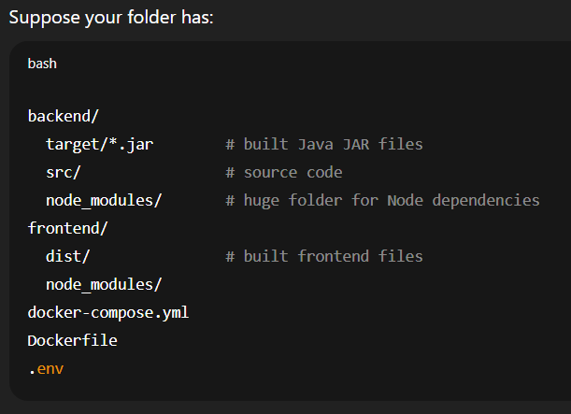
This files as u runed the project earlier
So its wise to use github clone in vm
Follow github clone methode to deploy

